Kingston FURY Renegade PCIe 4.0 NVMe M.2 SSD
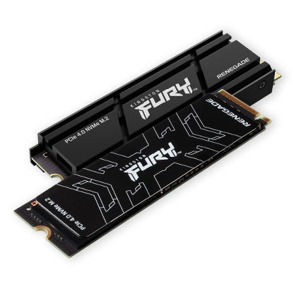
Key Features:
- Unmatched Speed: Sequential read/write speeds of up to 7,300/7,000 MB/s, ensuring fast load times and improved multitasking.
- Capacities: Available in 500GB, 1TB, 2TB, and 4TB, offering flexible storage solutions for games, media, and applications.
- Optimized for PCIe 4.0: Delivers twice the performance of PCIe 3.0 SSDs, making it future-proof and ideal for high-end setups.
Compatibility:
- Works seamlessly with PS5 consoles (requires system software version 21.02-04.00.00 or later).
- Compatible with desktops and laptops that support M.2 2280 form factor and PCIe 4.0 slot

Ideal For:
- High-performance gaming setups.
- Video editing, rendering, and other data-intensive tasks.
- Building custom PCs that prioritize speed and efficiency.
Warranty:
- Coverage against defects in materials and workmanship.

